**Relax Data Challenge**

I have found that the most important factor in predicting future user adoption is the time at which the user last logged in. We can see from the figure below that, the second most important factor is the organization the user belongs to.

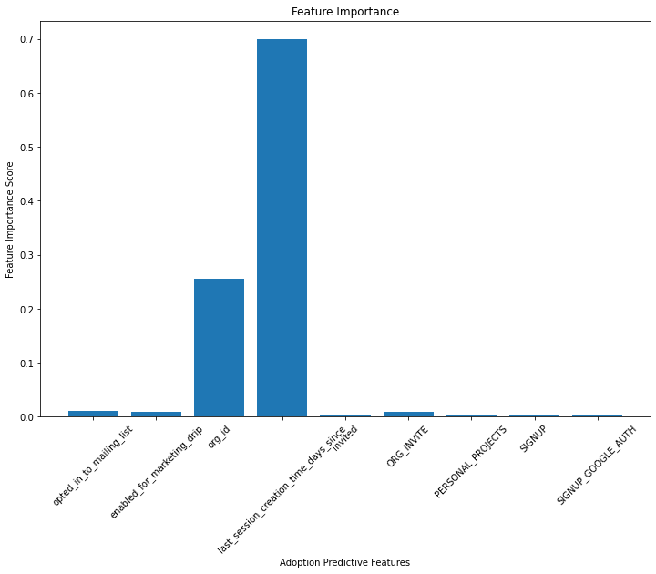

Digging a little deeper into that feature, those with more recent login times indicate a higher correlation with becoming an adopted user. This shows that whatever change the company has made most recently, has proven effective in retaining user engagement. The boxplot shows that the average user that can be defined as an adopted user are all heavily within the last 50 days of the data collected.